**Bharadwaja**

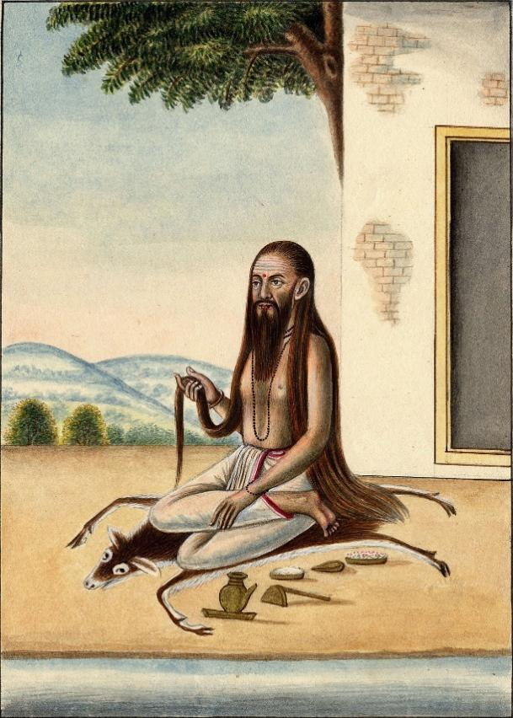

Bharadwaja also spelled Bhardwaj ( Sanskrit: भरद्वाज ), was one of the greatest Hindu sages (Maharishis) descendant of Rishi Angirasa, whose accomplishments are detailed in the Puranas. He is one of the Saptarshis (Seven Great Sages or Rishis) in the present Manvantara; with others being Atri, Vashishtha, Vishvamitra, Gautama, Jamadagni, Kashyapa

Bharadvaja Barhaspatya is the progenitor of the Bharadvaja family and the family is attributed as the composers of Sixth Maṇḍala of the Ṛgveda. Maṇḍala 6 is known as the Bharadvaja Family Book as all its 75 hymns are composed by a member of this family over several centuries. He is believed to be a contemporary of King Bhārata. Maharṣi Bharadvaja and his descendants were respected and powerful priests-like of several clans/dynasties of the Puru tribe, such as the Bharatas and the Pancalas.

Sage Bharadvaja was a sage of the Vedic times. He attained extraordinary scholarship. He had the great power of meditation. He is also the author of Ayurveda. His Ashrama still exists at the holy Prayag (Allahabad).

Another Bharadvaja Ṛiṣhi, a remote descendant of the progenitor, probably a disciple of Valmiki Muni, was father of Guru Droṇacharya and grandfather of Aśvatthāma from the epic Mahābhārata.

**History**

His full name in Vedic texts is *Bharadvaja Barhaspatya*, the last name referring to his father and Vedic deity-sage [Brihaspati](https://en.wikipedia.org/wiki/Brihaspati" \o "Brihaspati). His mother was Mamata, wife of Utathya Rishi who was the elder brother of Barhaspati. Guru Droṇācārya, the royal guru to Kauravas and Pāṇḍavas in the epic Mahābhārata was the son of sage Bharadvāja. He was a master of advanced military arts, including the Devāstras.

Among all the seven gotras Bharadvāja is the largest chain. Bharadvāja gotra has more than 1400 branches. One of the largest branch is Kankodyla. this branch originated from Bhadurgarh. In modern India there are several lacks of Bhardwaj who are religiously following the roots. One such person is Vinod Bhardwaj, who is working towards the enlightenment of "Kankodyla" shakha. He is the head of the organistaion Kankodyla Uthhan.

**The Gotra**

He is also accredited with the Bharadwaja Gotra, and the Bradardwaja Brahmins are known to be the highest class of Brahmins. People in his gotra are said to have warrior like quality as the sage married a Kshatriya girl named Suseela. This union is called Anuloma marriage,where the children although born to a brahmin father take the characteristics of the Kshatriya mother. The Brahmins of this gotra are thus also called as Brahma-Kshatriyas. Brahaspati was the son of Sage Angirasa and together with Bharadwaja the three are known as the Traya Rishis of the Bharadwaja gotra, which has about 1,400 branches today.

**Blessings from Indra**

He did austere penance to please Indra, who pleased with the devotion appeared before him. The penance was so great that he gave up food and water and nothing affected him be it heat or cold, rain or storm, he continued his penance.

In spite of the repeated blessings from Indra after repeated penances and austerities, his quest for knowledge did not end. Finally, when Indra appeared again in front of Bharadwaja there also appeared three mountain-sized masses of radiance. Indra picked a handful from each mass and gave it to Bharadwaj into him palms. This mass was quickly absorbed into him and he shown with a brilliance untold and he felt a new vigor. Indra explained to him that the three mountain like mass represented the three Vedas and even with a handful of it, he shone with more radiance than the gods. He explained that knowledge was boundless. . Sparsely clothed but with a serene face that emitted radiance he returned to the Marudgunas and prostrated before them and took their blessings.

He gave back to the world this knowledge of the Vedas he was blessed with and worked toward the welfare of the people.

**His Texts**

Bharadvaja and his family of students are 55. Bharadvaja and his family of students were the traditional poets of king Marutta of the Vedic era, in the Hindu texts.

Bharadvaja is a revered sage in the Hindu traditions, and like other revered sages, numerous treatises composed in the ancient and medieval eras are reverentially named after him. Some treatises named after him or attributed to him include:

* *Dhanur-veda*, credited to Bharadvaja in chapter 12.203 of the *Mahabharata*, is an Upaveda treatise on archery.
* *Bharadvaja samhita*, a [Pancharatra](https://en.wikipedia.org/wiki/Pancharatra" \o "Pancharatra) text (an [Agama](https://en.wikipedia.org/wiki/Agama_(Hinduism)" \o "Agama (Hinduism)) text of [Vaishnavism](https://en.wikipedia.org/wiki/Vaishnavism" \o "Vaishnavism)).
* *Bharadvaja srautasutra and grhyasutra*, a ritual and rites of passage text from 1st millennium BCE. After the *Kalpasutra* by Baudhayana, these Bharadvaja texts are among the oldest *srauta* and *grhya* sutras known.
* Sections in *Ayurveda*. Bharadvaja theories on medicine and causal phenomenon is described in *[Charaka Samhita](https://en.wikipedia.org/wiki/Charaka_Samhita" \o "Charaka Samhita)*. Bharadvaja states, for example, that an embryo is not caused by wish, prayers, urging of mind or mystical causes, but it is produced from the union of a man's sperm and menstrual blood of a woman at the right time of her menstrual cycle, in her womb. According to [Gerrit Jan Meulenbeld](https://en.wikipedia.org/wiki/Gerrit_Jan_Meulenbeld" \o "Gerrit Jan Meulenbeld), Bharadvaja is credited with many theories and practical ideas in ancient Indian medicine.
* *Niti sastra*, a treatise on ethics and practical conduct.
* *Bharadvaja-siksa*, is one of many ancient Sanskrit treatises on phonetics.

**His Role in Ramayana**

In Rāmāyaṇa, Śrī Rāma along with Sita and Lakṣmaṇa went on exile for the words of his father. Rama along with them went through many forest regions starting from crossing Saryu river with help of Guhan, head clanman and a friend of Rama's father Daśaratha.

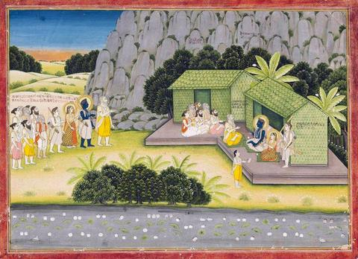

As he traveled he visited many Rishi's Ashrams and met many rishis and sages including Agastya, Gautama and Bharadvāja. Śrī Rāma and others rested in Bharadvāja's āśrama when they were crossing Prayag and accepted his offerings as great sages knew that Śrī Rāma is incarnation of Mahā Viṣṇu, Sātā Devī is goddess Lakṣmī and Lakṣmaṇa is none other than Śeṣha Nāga.

**Witnessing the Divine Dance**

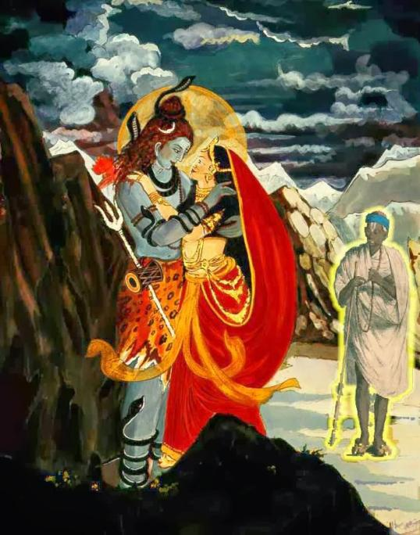Lord of the devas Indra asked Bharadwaja to to seek the blessing of Lord Shiva for his Yagna which was equivalent to mastering the Vedas. For that purpose he went to see Lor Shiva at Kailash. He witnessed the Lord engrossed in the divine dance with Parvati Devi. As he approached the Devi smiled at him.

He waited for days together for them to finish the dance and by that time the sage who was waiting without food water and sleep collapsed.